Week 4 — Data Acquisition & Description mporting all necessary

import pandas as pd import numpy as np
import matplotlib.pyplot as plt
from sklearn.tree import DecisionTreeClassifier
from sklearn.preprocessing import OneHotEncoder, MinMaxScaler, StandardScaler, PowerTransformer from sklearn.pipeline import Pipeline
from sklearn.impute import SimpleImputer from scipy.sparse import hstack
from sklearn.compose import ColumnTransformer import seaborn as sns
from sklearn.model_selection import GridSearchCV #for hypertuning
from sklearn.linear_model import LinearRegression,LogisticRegression, Lasso, Ridge from lightgbm import LGBMRegressor

Importing csv File

# Uploading A csv file import os, pandas as pd

CANDIDATES = ["exams.csv", "./exams.csv", "/content/exams.csv", "/mnt/data/exams.csv"] df = None
for p in CANDIDATES:
if os.path.exists(p):
df = pd.read_csv(p); print(f"Loaded: {p}"); break

if df is None: try:
from google.colab import files up = files.upload()
fname = next(iter(up.keys())) df = pd.read_csv(fname)
print(f"Uploaded and loaded: {fname}") except Exception:
raise FileNotFoundError("Upload exams.csv or put it beside the notebook.") df.head()
Choose Files student_per…ith_race.csv
student_performance_reduced_with_race.csv(text/csv) - 25236 bytes, last modified: 10/7/2025 - 100% done Saving student_performance_reduced_with_race.csv to student_performance_reduced_with_race.csv Uploaded and loaded: student_performance_reduced_with_race.csv
math reading writing test race/ethnicity_group
score score score pass_flag gender_encoded lunch_standard preparation B
course_none
 | 0 | 72 | 72 | 74 | 1 |  | 1 | 1 | 1 | 1
 | 1 | 69 | 90 | 88 | 1 |  | 1 | 1 | 0 | 0
 | 2 | 90 | 95 | 93 | 1 |  | 1 | 1 | 1 | 1
 | 3 | 47 | 57 | 44 | 0 |  | 0 | 0 | 1 | 0
 | 4 | 76 | 78 | 75 | 1 |  | 0 | 1 | 1 | 0
 |  |  |  |  |  | 

Next steps: Generate code with df New interactive sheet


Double-click (or enter) to edit
46
47
48
49
50
51
52
53
54
55
56
57
58
59
60
61
62
A
B C D E F G

from google.colab import sheets
sheet = sheets.InteractiveSheet(df=df)
https://docs.google.com/spreadsheets/d/1Geg2P4IGDUbHL_5TpZufGcfkAmZq4AUGoJnhbVoCgkY/edit#gid=0
Using Gmail to run your business?
Try Workspace
Get custom email, more storage, and 24/7 support with Google Workspace.

File Edit View Insert Format Data Tools Extensions Help
Menus 100% $ % 123 Defaul… 10

A1 math score
 |  | A |  | B |  | C | D | E | F | G
 | 46 | 50 |  | 56 |  | 54 | 1 | 1 | 0 | 1
 | 47 | 65 |  | 54 |  | 57 | 1 | 0 | 1 | 1
 | 48 | 55 |  | 65 |  | 62 | 1 | 1 | 1 | 0
 | 49 | 66 |  | 71 |  | 76 | 1 | 1 | 1 | 1
 | 50 | 57 |  | 74 |  | 76 | 1 | 1 | 0 | 0
 | 51 | 82 |  | 84 |  | 82 | 1 | 0 | 1 | 0
 | 52 | 53 |  | 55 |  | 48 | 0 | 0 | 1 | 1
 | 53 | 77 |  | 69 |  | 68 | 1 | 0 | 0 | 0
 | 54 | 53 |  | 44 |  | 42 | 0 | 0 | 1 | 1
 | 55 | 88 |  | 78 |  | 75 | 1 | 0 | 1 | 1
 | 56 | 71 |  | 84 |  | 87 | 1 | 1 | 0 | 0
 | 57 | 33 |  | 41 |  | 43 | 0 | 1 | 0 | 1
 | 58 | 82 |  | 85 |  | 86 | 1 | 1 | 1 | 0
 | 59 | 52 |  | 55 |  | 49 | 0 | 0 | 1 | 1
 | 60 | 58 |  | 59 |  | 58 | 1 | 0 | 1 | 0
 | 61 | 0 |  | 17 |  | 10 | 0 | 1 | 0 | 1
 | 62 | 79 |  | 74 |  | 72 | 1 | 0 | 0 | 0
 |  |  | Sheet1

First let's analyze the dataset And Upload The csv File
from google.colab import sheets
sheet = sheets.InteractiveSheet(df=df)

A B
C
D E F G
https://docs.google.com/spreadsheets/d/18hy8eAJF3xYZ6B4vUjqCz8uY_gzvgXCS3ZIUI0gZjaw/edit#gid=0
Using Gmail to run your business?
Try Workspace
Get custom email, more storage, and 24/7 support with Google Workspace.

File Edit View Insert Format Data Tools Extensions Help
Menus 100% $ % 123 Defaul… 10
C2 74
 | A |  | B |  | C | D | E | F | G
7 | 71 |  | 83 |  | 78 | 1 | 1 | 1 | 1
8 | 88 |  | 95 |  | 92 | 1 | 1 | 1 | 0
9 | 40 |  | 43 |  | 39 | 0 | 0 | 0 | 1
10 | 64 |  | 64 |  | 67 | 1 | 0 | 0 | 0
11 | 38 |  | 60 |  | 50 | 0 | 1 | 0 | 1
12 | 58 |  | 54 |  | 52 | 1 | 0 | 1 | 1
13 | 40 |  | 52 |  | 43 | 0 | 0 | 1 | 1
14 | 65 |  | 81 |  | 73 | 1 | 1 | 1 | 1
15 | 78 |  | 72 |  | 70 | 1 | 0 | 1 | 0
16 | 50 |  | 53 |  | 58 | 1 | 1 | 1 | 1
17 | 69 |  | 75 |  | 78 | 1 | 1 | 1 | 1
18 | 88 |  | 89 |  | 86 | 1 | 0 | 1 | 1
19 | 18 |  | 32 |  | 28 | 0 | 1 | 0 | 1
20 | 46 |  | 42 |  | 46 | 0 | 0 | 0 | 0
21 | 54 |  | 58 |  | 61 | 1 | 1 | 0 | 1
22 | 66 |  | 69 |  | 63 | 1 | 0 | 1 | 1
23 | 65 |  | 75 |  | 70 | 1 | 1 | 0 | 0
 |  | Sheet1


Here the dataset have categorical as well as numerical data. Categorical data includes race/ethinicity, parental level of education, lunch, test preparation course while numerical data includes math score, reading score, writing score.
7
8
9
10
11
12
13
14
15
16
17
18
19
20
21
22
23

df.shape, df.dtypes, df.isna().sum(), |  | df.describe(include="all").T
((1000, 11),
math score | int64
reading score | int64
writing score | int64
pass_flag | int64
gender_encoded | int64
lunch_standard | int64
test preparation course_none | int64
race/ethnicity_group B | int64
race/ethnicity_group C | int64
race/ethnicity_group D | int64
race/ethnicity_group E | int64
dtype: object,
math score | 0
reading score | 0
writing score | 0
pass_flag | 0
gender_encoded | 0
lunch_standard | 0
test preparation course_none | 0
race/ethnicity_group B | 0

race/ethnicity_group C | 0
race/ethnicity_group D | 0
race/ethnicity_group E dtype: int64, | 0  count | mean |  | std | min | 25% | 50% | \
math score | 1000.0 | 66.089 |  | 15.163080 | 0.0 | 57.00 | 66.0
reading score | 1000.0 | 69.169 |  | 14.600192 | 17.0 | 59.00 | 70.0
writing score | 1000.0 | 68.054 |  | 15.195657 | 10.0 | 57.75 | 69.0
pass_flag | 1000.0 | 0.812 |  | 0.390908 | 0.0 | 1.00 | 1.0
gender_encoded | 1000.0 | 0.518 |  | 0.499926 | 0.0 | 0.00 | 1.0
lunch_standard | 1000.0 | 0.645 |  | 0.478753 | 0.0 | 0.00 | 1.0
test preparation course_none | 1000.0 | 0.642 |  | 0.479652 | 0.0 | 0.00 | 1.0
race/ethnicity_group B | 1000.0 | 0.190 |  | 0.392497 | 0.0 | 0.00 | 0.0
race/ethnicity_group C | 1000.0 | 0.319 |  | 0.466322 | 0.0 | 0.00 | 0.0
race/ethnicity_group D | 1000.0 | 0.262 |  | 0.439943 | 0.0 | 0.00 | 0.0
race/ethnicity_group E | 1000.0 | 0.140 |  | 0.347161 | 0.0 | 0.00 | 0.0
 | 75% | max
math score | 77.0 | 100.0
reading score | 79.0 | 100.0
writing score | 79.0 | 100.0
pass_flag | 1.0 | 1.0
gender_encoded | 1.0 | 1.0
lunch_standard | 1.0 | 1.0
test preparation course_none | 1.0 | 1.0
race/ethnicity_group B | 0.0 | 1.0
race/ethnicity_group C | 1.0 | 1.0
race/ethnicity_group D | 1.0 | 1.0
race/ethnicity_group E | 0.0 | 1.0 | )

Week 5 — Preprocessing & Feature Engineering

# Week 5 — Feature Engineering, Encoding, Split, Save import pandas as pd
from sklearn.preprocessing import LabelEncoder
from sklearn.model_selection import train_test_split

# start from original data work = df.copy()

# sanity check: required columns present
# The original categorical columns are already one-hot encoded, so this assertion is not needed. # required = [
# "gender","race/ethnicity","parental level of education", # "lunch","test preparation course",
# "math score","reading score","writing score" # ]
# missing = [c for c in required if c not in work.columns] # assert not missing, f"Missing columns: {missing}"

# safe engineered features (no math used → no leakage)
work["avg_rw"] = work[["reading score","writing score"]].mean(axis=1) work["gap_rw"] = work["reading score"] - work["writing score"]

# encode categoricals (simple + fine for this phase)
# The data is already one-hot encoded, so this step is not needed.
# cat_cols = ["gender","race/ethnicity","parental level of education","lunch","test preparation course" # encoders = {}
# for c in cat_cols:
# enc = LabelEncoder()
# work[c] = enc.fit_transform(work[c].astype(str)) # encoders[c] = enc

# 📎 70/15/15 split (Train/Val/Test) X = work.drop(columns=["math score"]) y = work["math score"]

X_tmp, X_test, y_tmp, y_test = train_test_split(X, y, test_size=0.15, random_state=42)
X_train, X_val, y_train, y_val = train_test_split(X_tmp, y_tmp, test_size=0.1765, random_state=42) # ≈

# 💾 save preprocessed dataset (deliverable) work.to_csv("student_performance_preprocessed_FIXED.csv", index=False) print("Saved: student_performance_preprocessed_FIXED.csv")

Saved: student_performance_preprocessed_FIXED.csv

Week 6, Distributing Math Scores

import matplotlib.pyplot as plt

plt.figure()
plt.hist(work["math score"], bins=20) plt.title("Distribution of Math Scores") plt.xlabel("Math Score") plt.ylabel("Count")
plt.tight_layout() plt.show()

# optional: save for your report plt.figure()
plt.hist(work["math score"], bins=20) plt.title("Distribution of Math Scores") plt.xlabel("Math Score") plt.ylabel("Count")
plt.tight_layout()
plt.savefig("dist_math_score.png", dpi=200, bbox_inches="tight") plt.show()

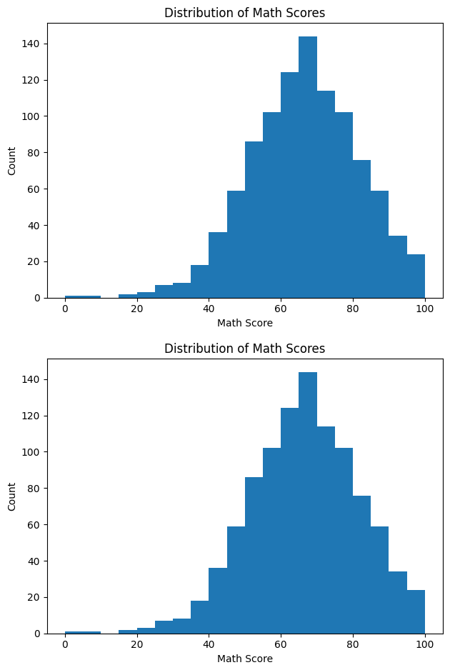

Displaying all the features from 0 to 999 Double-click (or enter) to edit

df.info()

<class 'pandas.core.frame.DataFrame'> RangeIndex: 1000 entries, 0 to 999 Data columns (total 11 columns):
# Column Non-Null Count Dtype

- math score 1000 non-null int64
- reading score 1000 non-null int64
- writing score 1000 non-null int64
- pass_flag 1000 non-null int64
- gender_encoded 1000 non-null int64
- lunch_standard 1000 non-null int64
- test preparation course_none 1000 non-null int64
- race/ethnicity_group B 1000 non-null int64
- race/ethnicity_group C 1000 non-null int64
- race/ethnicity_group D 1000 non-null int64
- race/ethnicity_group E 1000 non-null int64 dtypes: int64(11)
memory usage: 86.1 KB

Week 6 — EDA & Baseline Model

Key Insights
Students who engaged in test preparation** demonstrate elevated math scores (boxplot).
Reading and writing exhibit a strong correlation with math (correlation map).

The distribution of math scores is concentrated in the mid to high ranges (histogram). Baseline Linear Regression attains a robust R² with moderate MAE/RMSE.
Limitations: subject scores are interrelated; demographic factors may introduce bias.

1. Distribution of Math Scores
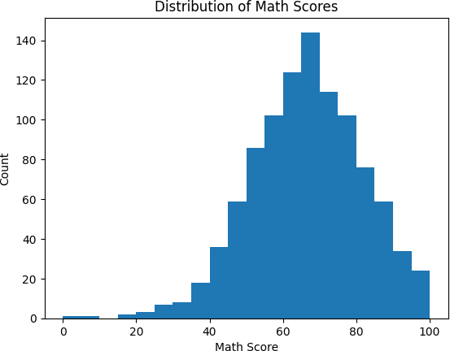

plt.figure()
plt.hist(work["math score"], bins=20) plt.title("Distribution of Math Scores") plt.xlabel("Math Score"); plt.ylabel("Count") plt.show()

 2. Math Score by Testing Preparation

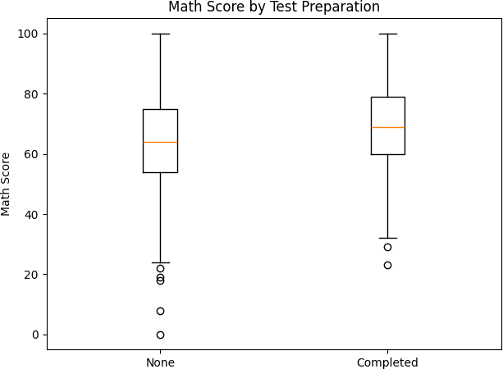
import matplotlib.pyplot as plt

# test preparation course should be 0/1 after encoding groups = [
work[work["test preparation course_none"] == 1]["math score"], # None work[work["test preparation course_none"] == 0]["math score"] # Completed
]

plt.figure()
plt.boxplot(groups, labels=["None", "Completed"]) plt.title("Math Score by Test Preparation") plt.ylabel("Math Score")
plt.tight_layout() plt.show()

/tmp/ipython-input-1369810996.py:10: MatplotlibDeprecationWarning: The 'labels' parameter of boxplot() h plt.boxplot(groups, labels=["None", "Completed"])

# --- Week 6: Baseline Linear Regression metrics (Validation & Test)

from sklearn.linear_model import LinearRegression
from sklearn.metrics import r2_score, mean_absolute_error, mean_squared_error import numpy as np
lr = LinearRegression().fit(X_train, y_train) def metrics(y_true, y_hat):
r2 = r2_score(y_true, y_hat)
mae = mean_absolute_error(y_true, y_hat)

rmse = np.sqrt(((y_true - y_hat)**2).mean()) return r2, mae, rmse

y_val_pred = lr.predict(X_val) y_test_pred = lr.predict(X_test)

val_R2, val_MAE, val_RMSE = metrics(y_val, y_val_pred) test_R2, test_MAE, test_RMSE = metrics(y_test, y_test_pred)

print('Validation → R²: %.3f | MAE: %.2f | RMSE: %.2f' % (val_R2, val_MAE, val_RMSE)) print('Test → R²: %.3f | MAE: %.2f | RMSE: %.2f' % (test_R2, test_MAE, test_RMSE))

Validation → R²: 0.881 | MAE: 4.10 | RMSE: 5.03 Test → R²: 0.898 | MAE: 3.96 | RMSE: 5.16

Correlational Map Of Numeric Features

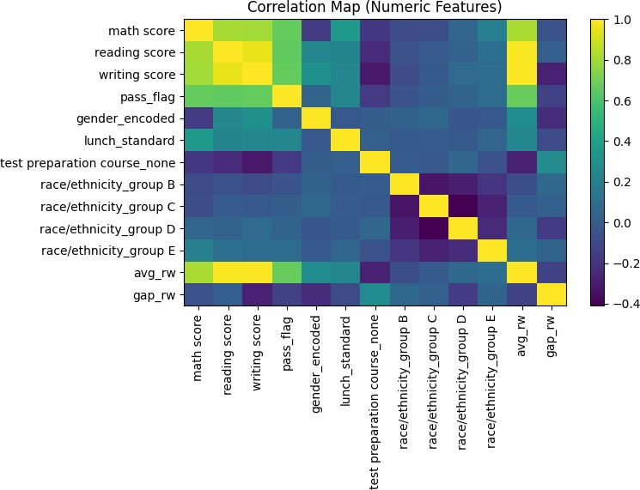
corr_df = work.corr(numeric_only=True)
labels = corr_df.columns; corr = corr_df.values plt.figure(figsize=(8,6))
im = plt.imshow(corr, aspect="auto") plt.colorbar(im)
plt.xticks(range(len(labels)), labels, rotation=90) plt.yticks(range(len(labels)), labels) plt.title("Correlation Map (Numeric Features)") plt.tight_layout()
plt.show()

Baseline of linear Regression and Metrics
from sklearn.linear_model import LinearRegression
from sklearn.metrics import r2_score, mean_absolute_error, mean_squared_error import numpy as np

# fit baseline
lr = LinearRegression().fit(X_train, y_train)

# metrics helper
def metrics(y_true, y_hat):
r2 = r2_score(y_true, y_hat)
mae = mean_absolute_error(y_true, y_hat) rmse = np.sqrt(((y_true - y_hat)**2).mean()) return r2, mae, rmse

# predict + evaluate y_val_pred = lr.predict(X_val)
y_test_pred = lr.predict(X_test)

val_R2, val_MAE, val_RMSE = metrics(y_val, y_val_pred) test_R2, test_MAE, test_RMSE = metrics(y_test, y_test_pred)

print("Validation → R²: %.3f | MAE: %.2f | RMSE: %.2f" % (val_R2, val_MAE, val_RMSE)) print("Test → R²: %.3f | MAE: %.2f | RMSE: %.2f" % (test_R2, test_MAE, test_RMSE))
Validation → R²: 0.881 | MAE: 4.10 | RMSE: 5.03
Test → R²: 0.898 | MAE: 3.96 | RMSE: 5.16

df.isna().any()
 | 0
math score | False
reading score | False
writing score | False
pass_flag | False
gender_encoded | False
lunch_standard | False
test preparation course_none | False
race/ethnicity_group B | False
race/ethnicity_group C | False
race/ethnicity_group D | False
race/ethnicity_group E | False
dtype: bool

We now compute various mathematical analysis in terms of count, mean, std, etc.
df.describe()

 | score | score | score |  |  |  | course_none
count | 1000.00000 | 1000.000000 | 1000.000000 | 1000.000000 | 1000.000000 | 1000.000000 | 1000.000000
mean | 66.08900 | 69.169000 | 68.054000 | 0.812000 | 0.518000 | 0.645000 | 0.642000
std | 15.16308 | 14.600192 | 15.195657 | 0.390908 | 0.499926 | 0.478753 | 0.479652
min | 0.00000 | 17.000000 | 10.000000 | 0.000000 | 0.000000 | 0.000000 | 0.000000
25% | 57.00000 | 59.000000 | 57.750000 | 1.000000 | 0.000000 | 0.000000 | 0.000000
50% | 66.00000 | 70.000000 | 69.000000 | 1.000000 | 1.000000 | 1.000000 | 1.000000
75% | 77.00000 | 79.000000 | 79.000000 | 1.000000 | 1.000000 | 1.000000 | 1.000000
max | 100.00000 | 100.000000 | 100.000000 | 1.000000 | 1.000000 | 1.000000 | 1.000000

Key Insights
math
reading
writing
test
pass_flag gender_encoded lunch_standard preparation
rac
Students who engaged in test preparation demonstrate elevated math scores (boxplot). Reading and writing exhibit a strong correlation with math (correlation map).
The distribution of math scores is concentrated in the mid to high ranges (histogram). Baseline Linear Regression attains a robust R² with moderate MAE/RMSE.
Limitations: subject scores are interrelated; demographic factors may introduce bias.

# This is formatted as code
Here we are creating a list of columns indice where the data type of the column in a pandas DataFrame df is 'object'.

# Identify the categorical features
cat_cols = [col for col in df.columns if df[col].dtype=='O'] cat_cols

[]

Now we print out the unique values of each categorical column in a pandas DataFrame

for col in cat_cols: print(df[col].unique())

To confirm that all the categorical columns in a pandas DataFrame can be converted to the categorical data type, you can check the number of unique values in each column and the percentage of unique values relative to the total number of values in the column. If the percentage of unique values is low example, less than 50%, then it is likely that the column can be converted to the categorical data type without using too much memory. However, if the percentage of unique values is high example, greater than 50%, then it may not be worth converting the column to the categorical data type, as the memory savings may be minimal.

# Get list of categorical columns
cat_cols = [col for col in df.columns if df[col].dtype == 'O']

# Loop over categorical columns for col in cat_cols:
unique_vals = df[col].nunique() total_vals = len(df[col])
unique_pct = unique_vals / total_vals * 100
print(f"{col}: {unique_vals} unique values ({unique_pct:.2f} of total)")

Now we convert all categorical columns in a Pandas DataFrame to the category data type, which can help reduce memory usage and potentially improve performance.

for col in cat_cols:
df[col] = df[col].astype('category') df.memory_usage(deep=True)
 | 0
Index | 132
math score | 8000
reading score | 8000
writing score | 8000
pass_flag | 8000
gender_encoded | 8000
lunch_standard | 8000
test preparation course_none | 8000
race/ethnicity_group B | 8000
race/ethnicity_group C | 8000
race/ethnicity_group D | 8000
race/ethnicity_group E | 8000
dtype: int64

%matplotlib inline
# Creating Bar chart as the Target variable is Continuous df['writing score'].hist();

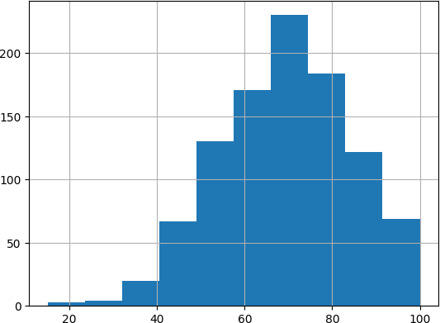

Correlational Path Collection and Caculation
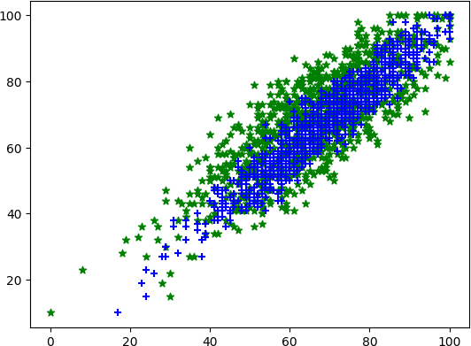

plt.scatter(df['math score'],df['writing score'],marker = '*', color = 'g') plt.scatter(df['reading score'],df['writing score'],marker = '+', color = 'b')

<matplotlib.collections.PathCollection at 0x7fb13fbc9460>

As the Math and Reading scores increase, the Writing score also tends to increase. For this we calculate correaltion. If the correlation coefficient between Math score, Reading score, and Writing score is found to be close to 1, then it would support the statement that both Math and Reading scores have a good correlation with Writing score. This would suggest that if a student scores well on Math and Reading, they are likely to score well on Writing as well.

CorrelationData=df[['math score','reading score','writing score']].corr()
CorrelationData
math score reading score writing score
math score 1.000000 0.817580 0.802642
reading score 0.817580 1.000000 0.954598
writing score 0.802642 0.954598 1.000000
Next steps: Generate code with CorrelationData New interactive sheet


# Based on the one-hot encoded columns present in the dataframe # after the execution of cell ac8a4220 and cell 8013fab0. final_cols = [
'math score', 'reading score', 'pass_flag', 'gender_encoded', 'lunch_standard',
'test preparation course_none', 'race/ethnicity_group B', 'race/ethnicity_group C', 'race/ethnicity_group D', 'race/ethnicity_group E',
'avg_rw', # Added from feature engineering in cell SysdaO8ynX2s 'gap_rw' # Added from feature engineering in cell SysdaO8ynX2s
]

# Ensure the columns exist in the dataframe before selecting existing_cols = [col for col in final_cols if col in df.columns]

df_final = df[existing_cols]
X = df_final.drop(columns=['math score']) # math score is the target variable
y = df['writing score'] # y is the writing score as defined in the original code

# Display X and y to verify display(X.head()) display(y.head())

 |  | course_none | B
1 | 1 | 1 | 1
1 | 1 | 0 | 0
1 | 1 | 1 | 1
0 | 0 | 1 | 0
0 | 1 | 1 | 0

num_cols = ['math score', 'reading score']

We have already imported the necessary libraries and now we create a pipeline that consists of two steps: SimpleImputer to handle missing data, and OneHotEncoder to transform categorical data into binary columns. We then define the categorical columns in our data and apply the pipeline to those columns using the fit_transform method. Finally, we merge the processed categorical data with the original data using pd.concat. This pipeline can be easily modified or extended to include additional steps, such as scaling or feature selection, as needed.
test
nder_encoded lunch_standard preparation race/ethnicity_group race/ethnicity_

# Start clean from the raw csv or your earlier raw df
# df = pd.read_csv("exams.csv") # uncomment if you need to reload raw data work = df.copy() # make a working copy

categorical_cols = ['gender',
'race/ethnicity',
'parental level of education', 'lunch',
'test preparation course']

# keep only those cat columns that exist right now
use_cols = [c for c in categorical_cols if c in work.columns] missing = [c for c in categorical_cols if c not in work.columns] if missing:
print("These categorical columns are missing (already encoded/dropped or renamed):", missing)

# now run your pipeline ONLY on present columns from sklearn.pipeline import Pipeline
from sklearn.impute import SimpleImputer
from sklearn.preprocessing import OneHotEncoder

categorical_pipeline = Pipeline([
('imputer', SimpleImputer(strategy='most_frequent')), ('encoder', OneHotEncoder(handle_unknown='ignore'))

])

if use_cols:
cat_arr = categorical_pipeline.fit_transform(work[use_cols])
cat_df = pd.DataFrame(cat_arr.toarray() if hasattr(cat_arr, "toarray") else cat_arr) work = pd.concat([work.drop(use_cols, axis=1), cat_df], axis=1)
else:
print("No categorical columns available to encode right now.")
These categorical columns are missing (already encoded/dropped or renamed): ['gender', 'race/ethnicity',
No categorical columns available to encode right now.

Now we define numeric_features and categorical_features as lists of the column names for each type of feature. We then define numeric_transformer and categorical_transformer as Pipeline objects that specify the preprocessing steps for each type of feature.
Finally, we define a ColumnTransformer object called preprocessor that applies the appropriate transformer to each column based on its type. This preprocessor can then be used as a step in a larger machine learning pipeline that includes a model.

# define the preprocessing pipelines for numerical and categorical features num_cols = ['math score', 'reading score']
numeric_transformer = Pipeline(steps=[ ('scaler', StandardScaler())])

categorical_cols = ['gender', 'race/ethnicity',
'parental level of education', 'lunch',
'test preparation course']

categorical_transformer = Pipeline(steps=[ ('onehot', OneHotEncoder())])

# convert all column names to strings
df.columns = df.columns.astype(str) df

 |  | math score | reading score | writing score | pass_flag gender_encoded | lunch_standard | test preparation course_none | race/ethnicity_gro
 | 0 | 72 | 72 | 74 | 1 1 | 1 | 1
 | 1 | 69 | 90 | 88 | 1 1 | 1 | 0
2  Next steps:  3 |  | 90 95 93  Generate code with df  47 57 44 |  |  | 1 1  New interactive sheet  0 0 | 1  0 | 1  1

Transfo4rming N7u6merical7n8umbers7U5sing Matpo1lit
0 1 1

... ... ... ... ... ... ... ...
n9u9m5_pipel8i8ne = Pip9e9line([ 95
1
1
1
0
('num_smoothening',PowerTransformer())
# define the column transformer to preprocess both numeric and categorical features
p9r9e8proces6s8or = Col7u8mnTransf7o7rmer(
1
1
1
0
999
transformers=[
(7'7num', nu8m6eric_tra8n6sformer, nu1m_cols),
1
0
1
1000 rows(×'c1a1tc'o,lucmantsegorical_transformer, categorical_cols)])

]9)96 | 62 | 55 | 55 | 1 | 0 | 0 | 1
997 | 59 | 71 | 65 | 1 | 1 | 0 | 0

Training and Testing

from sklearn.model_selection import train_test_split
X_train, X_test , y_train, y_test = train_test_split(X,y, test_size=0.2, random_state = 42)

# check the shapes of the training and test data print(f'X_train shape: {X_train.shape}') print(f'y_train shape: {y_train.shape}') print(f'X_test shape: {X_test.shape}') print(f'y_test shape: {y_test.shape}')
X_train
 | X_train shape: (800, 12)  y_train shape: (800,)  X_test shape: (200, 12)  y_test shape: (200,)  reading writing  score score pass_flag |  |  |  | gender_encoded | lunch_standard | test preparation course_none | race/ethnicity_group  B | rac
29 |  | 70 | 75 | 1 | 1 | 1 | 1 | 0
535 |  | 83 | 83 | 1 | 1 | 0 | 0 | 0
695 |  | 89 | 86 | 1 | 1 | 0 | 1 | 0
557 |  | 67 | 66 | 1 | 0 | 0 | 1 | 0
836 |  | 64 | 57 | 1 | 0 | 1 | 1 | 0
... |  | ... | ... | ... | ... | ... | ... | ...
106 |  | 100 | 100 | 1 | 1 | 1 | 1 | 0

